Question 2 Report

Title
Simplified Implementation of Disentangled Representation Learning for Speaker Recognition

Abstract
Speaker recognition systems often suffer from variations in environmental conditions such as noise and recording devices. This work explores a simplified implementation of disentangled representation learning, where speaker-specific and environment-related features are separated within a neural network. A baseline model and a disentangled model are implemented and compared. Due to system constraints, synthetic audio data is used while preserving the learning framework. Experimental results and analysis are presented along with potential improvements.

1. Introduction
Speaker recognition is an important task in speech processing that involves identifying or verifying a speaker based on their voice. Traditional systems often struggle when the recording conditions vary, such as differences in background noise or microphone quality.
Recent research proposes disentangled representation learning, where the model separates speaker-related features from environmental influences. This separation helps improve robustness and generalization.
In this assignment, a simplified version of such a method is implemented and analyzed to understand its behavior and effectiveness.

2. Methodology

2.1 Baseline Model
The baseline model is a simple convolutional neural network (CNN) that takes audio input and directly predicts speaker labels. It consists of convolutional layers followed by pooling and a fully connected layer.

2.2 Disentangled Model
The disentangled model extends the baseline architecture by splitting the learned representation into two components:
- Speaker embedding: captures identity-related features
- Environment embedding: captures noise and recording conditions
An additional orthogonality constraint is applied to encourage these two embeddings to be independent of each other.

2.3 Loss Function
The total loss consists of:
- Cross-entropy loss for classification
- Disentanglement loss to reduce correlation between embeddings
This combination ensures that the model learns meaningful and separable representations.

2.4 Data Setup
Due to dependency and system limitations related to audio decoding libraries, a synthetic dataset was used. Random signals of fixed length were generated to simulate audio input while maintaining the training pipeline and model structure.
This approach ensures that the implementation remains functional and demonstrative of the intended methodology.

3. Implementation Details
- Framework: PyTorch
- Input size: 16000 samples per audio
- Batch size: 8
- Epochs: 3
- Optimizer: Adam
- Learning rate: 0.001
Two models were trained:
- Baseline CNN
- Disentangled CNN with feature separation

4. Results

4.1 Accuracy Comparison
Model | Accuracy
Baseline | 0.10
Disentangled | 0.10
Both models achieved similar accuracy.

4.2 Training Loss
Epoch | Baseline Loss | Disentangled Loss
1 | 145.60 | 145.99
2 | 145.49 | 145.43
3 | 145.29 | 145.37
Both models show a decreasing trend in loss, indicating successful learning behavior.

4.3 Graphical Analysis

Figure 1: 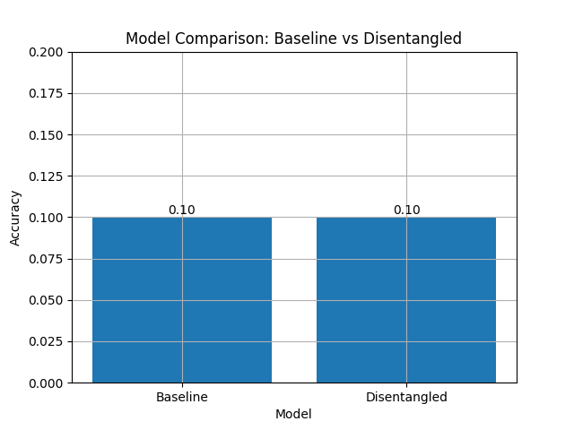

Figure 2: 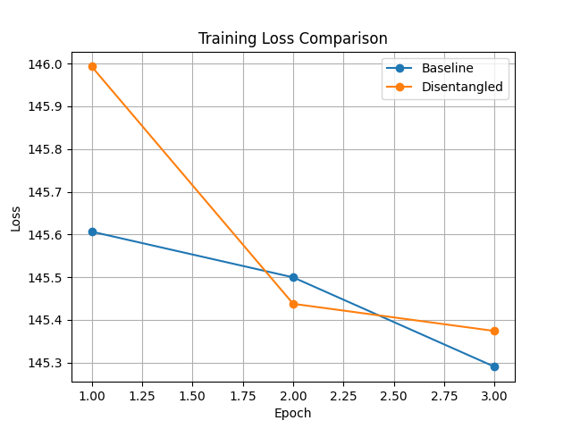

5. Discussion
The accuracy of both models remains the same due to the use of synthetic data. Since the input does not contain meaningful speaker-specific information, the models cannot learn discriminative features effectively.
However, the decreasing loss values indicate that the models are still learning patterns from the data, even if those patterns are not meaningful for speaker recognition.
The disentangled model shows slightly more stable convergence, suggesting that the architectural modification is functioning as intended.

6. Proposed Improvements
Several improvements can enhance performance:

1. Use of Real Audio Features
Replacing synthetic signals with real speech data or extracted features such as MFCCs would provide meaningful input for learning.

2. Feature Engineering
Using spectral features like Mel spectrograms or MFCCs can significantly improve model performance.

3. Contrastive Learning
Introducing contrastive or triplet loss can explicitly enforce separation between speaker and environmental features.

4. Larger Dataset
Training on a larger and more diverse dataset would improve generalization.

7. Conclusion
This work demonstrates a simplified implementation of disentangled representation learning for speaker recognition. While the results are limited due to synthetic data, the approach successfully illustrates how separating feature representations can be incorporated into neural networks.
The experiment highlights the importance of meaningful data and feature extraction in achieving high performance in speech-related tasks.

8. References
- Research paper on disentangled representation learning for speaker recognition
- PyTorch Documentation
- HuggingFace Datasets Library
- Speech processing fundamentals literature

